Literature Review
Petar Borisov 12431273
Supervisor Gertraud Malsiner-Walli

When it comes to stocks, no other event comes close to the amount of firm-specific information and uncertainty that the Quarterly Earnings Announcement generates. Academic research on returns surrounding Earnings Events is broad and well-documented. Larmon & Frazzini (2007) for example, document a sizable earnings announcement premium, where around 60% of a typical stock’s annual return can be captured by trading the t = -3 to t= 3 event window (t = 0 is the Earnings Announcement Day). Additionally, Savor & Wilson (2016) show that the US equity risk premium all but disappears if returns around EA windows are excluded. Similarly, Barber et al (2012) corroborate those findings by verifying a similar phenomenon in a cross section of 200 000 announcements in 20 different countries all over the globe. Therefore, Earnings Announcements (EAs) are an economically important event that also has real financial consequences for investors.
However, this thesis is not about verifying the economic significance of EAs but rather trading them and forecasting their magnitude. Hence, the rest of the literature review will focus on a rather niche topic – Options and how Option market dynamics relate to Earnings Announcements (EAs).
Option markets, and particularly the At the Money (ATM) Implied Volatility (IV) Curve can be used to ex-ante obtain an estimate of the expected magnitude of a scheduled event such as an EA or economic release (Govindaraj et al, 2014). A good example comes from Durbinsky et al (2018), who document that on the eve of the Brexit Vote on 23.06.2016 1-month and 2-month IV on GBPUSD was 28.21% and 21.51% respectively. This term structure implied an estimate of the magnitude of the scheduled event (Brexit Vote) of 7.45%, the day after the pound dropped by 7.6% - a near perfect ex-ante prediction of the realized move. Similarly, Kelly et al (2016) found similar results for the pricing of predictable national elections and global summits.
Therefore, the real question becomes whether the IV curve is an accurate predictor of EA realized moves as well. As early as 1979, Patel & Wolfson documented that IV of Option expirations close to Earnings Announcements rise predictably by a factor of T⁻¹, which results in the pattern where the ATM IV curve is downward slopping immediately before EA, allowing for an estimation of the 1-Day Expected Event Move using the additive property of variances and linear interpolation, where the assumption is that only the event day variance is significantly higher, while all the other daily variances are constant. Building on their work in 1981, Patel & Wolfson were also the first to note the that the IV crush, which is the predictable and very statistically significant drop in Implied Volatility after Earnings Announcements exists. This property of Option IV makes selling ATM Straddles (Short-Call and Short-Put of the same strike) into EAs particularly appealing for traders.
When discussing Options, one should not forget to mention the fact that Options tend to be on average overpriced, hence shorting options earns a risk premium. Goyal & Saretto (2009) provide information about it via a cross-sectional study, where they find that option returns reflect a premium for variance risk, calculated as the difference between historical realized volatility and lagged Implied Volatility – essentially pointing out that empirically there exists a Variance Risk Premium (VRP), which is required by market participants due to the non-linear payoff structure (limited profit, unlimited loss) for shorting options. Not only that but analysis such as that orchestrated by Bali et al (2021) show that delta-hedged short-option returns covering 12 million observations in the period 1996 -2020 earned on average a significant positive return, which once again provides evidence of the VPR. The authors also build predictive machine learning models for the profitability of delta-hedged options over a feature space of more than 300 variables and are able to successfully forecast and trade OoS short options for a positive return with an OoS Adjusted R-squared (for 300 variables) of 2.78%.
With this in mind, we can discuss the relationship between EAs and Option Trading. The idea behind trading options around earnings is to short an ATM Straddle of the closest expiration on the eve of the event (just before market close on the day before EA) and close the ATM Straddle the next trading day. The rational is that Option prices will plumet due to the IV crush (Short Options have negative Vega) and since Options tend to be overpriced (Variance Risk Premium), it is likely that the profit generated from the IV crush would outweigh the gamma loss in the underlying (Short Options are negative Gamma so any substantial move either up or down leads to losses). The literature is split on how to measure the move in the underlying i.e. what to use to compute the Gamma Loss. Most academic papers use the Pre-Event Close – to – Post-Event Open change as a measure of the earnings-related move, colloquially known as how much the stock gapped the day after the earnings were announced (discrete jump). This makes sense theoretically, but empirically this approach has a few flaws. Firstly, a lot of the earnings-related price movement occurs in the first few minutes after the earnings release, therefore the discrete jump from close to open does not fully encompass the pricing information in earnings (Patel & Wolfson, 1984). Secondly, in the first few minutes after open the bid-ask spread on options is so wide that for all intents and purposes trades can not be closed, so in practice any research developing a trading system, which assumes that the Short Straddles can be closed in the first 5 minutes after open are rather unrealistic. Thirdly, is data availability, the aim of this thesis is after all is to produce a pragmatic forecasting tool, which can be used to predict the magnitude of EA moves and trade them profitably. Currently, the only high-quality Options Data available for research consists of End of Day (Close) Prices from IvyDB, therefore making assumptions about closing ATM Straddles around the open or intraday is unreasonable.
Hence, the second approach of measuring the Earnings Realized Move (Pre – Event Close to Post – Event Close) is preferable and will be used throughout the thesis as the dependent variable (what we will forecast) and as a basis for calculating the Gamma Loss of Short Straddles. Lipkin & Tatevossian (2024) provide very valuable contribution on the topic. In their paper the authors stipulate that earnings realized moves (Close to Close) tend to form a symmetric distribution. The empirical distribution has fatter tails than the normal or Student-t and the best fit is offered by the Laplace distribution. Lipkin & Tatevossian (2024) employ a methodology similar to that of Durbinsky et al (2018) where they find that the ex-ante expected 1-day event move just before EA on average is larger than the subsequent 1-day realized move, which once again is indicative of the presence of a Variance Risk Premium (VRP). Despite this, they also document that for large-tailed moves i.e. earnings moves outside of the 2 Standard Deviation mark, tend to be predicted by similar ex-ante large tailed IV expected move 50-80% of the time depending on the year. It is important to note that Earnings Realized Moves do not operate in a vacuum and are a much more complicated event than standard economic theory would suggest. Firstly, Della Vigna & Pollet (2009) document that earnings released on days where there are a lot of other companies also releasing or on Fridays tend to have a 15% lower immediate response and a 70% higher delayed response. Simply said, they tend to gap less (smaller discrete jumps) and exhibit higher Post Earnings Announcement Drifts (PEADs) i.e. more movement after the open into the close and the subsequent days. They attribute this to the cognitive attention of investors which is a limited resource and can’t tract multiple company EAs at once. Similar findings of smaller gaps and larger PEAD were also reported by Hirschleifer et al (2009). Additionally, Rogers et al (2009) examine how management earnings forecast affect IV and posit that negative news tend to rise IV levels throughout the whole expiration chain i.e. reduce Short Straddle Vega Profit, while positive or neutral news do not have such effects. Effectively, Rogers et al (2009) show that EAs are not necessarily symmetric in terms of how the Straddle PNL evolves (we expect negative earnings releases to hurt Short Options strategy more than Positive or Neutral News). On top of that Barth & So (2010) identify Earnings Releases to be a source of non-diversifiable risk and show that EAs exhibit an additional risk premium additional to those already discussed (VRP and Equity Risk Premium).
Lei et al (2017) wrap up this discussion by empirically analyzing a panel of EAs and link higher pre-event volume trading to higher post-event discretionary jump (Close to Open Move). They posit that option trading increases the reaction to EA information and manifests in a bigger overnight move at the expense of smaller Post Earnings Announcement Drift (PEAD).
The most valuable part of the literature is saturated in 2 papers, which focus on predicting earnings move magnitude and crafting trading strategies around them. The first of those papers is by Diavtopolous et al (2012), who compute implied option chain skewness and kurtosis according to the approach of Bakshi & Kapadia (2003). Diavtopolous et al (2012) calculate the implied skewness and kurtosis and measure their change from t = - 30 to t = - 5 and find that changes in those moments have a strong predictive power for future stock returns in terms of direction and magnitude, even after controlling for Implied Volatility. They show that changes in Implied Skewness and Implied Kurtosis predict Call returns, while Put returns are only predicted by Implied Skewness.
The second and arguably most influential paper on the topic of trading option around EAs is by Dubinsky et al (2018). There the authors derive a plethora of very valuable findings. First is that earnings realized moves on average across the US stock market tend to be between 4-6% during normal times and around 10-11% during crisis, which shows high correlation to the business cycle and corroborates the findings of Rogers et al (2009) of the relationship between IV and negative news. Secondly, Dubinsky et al (2018) find that cross-sectional variation in earnings move magnitude among firms is less than 3% on average during normal times and jumps to more than 6% during recessions – implying greater heterogeneity. Thirdly, the authors find there to be a 53% correlation between ex-ante Estimates of the Expected 1-Day Event Move and the subsequent realized earnings move (Close to Close), which means that the IV term structure is predictive but there is a lot of room for improvement via non-linear models. Fourth, Dubinsky et al (2018) report that the average ex-ante implied earnings move for 2000-2015 was 8.22% while the average realized event move (Close to Close) was 7.42%, meaning that there is an 80 bps risk premium for selling options on earnings events, which is additional to the aforementioned variance risk premium and corroborates the findings of Barth & So (2010). Fifth, Dubinsky et al (2015) run a back test of buying long ATM straddles before the event and selling them on the close after the event (opposite of the strategy discussed so far) and find that this strategy yields an average loss of -7.96% of premium paid per quarter, which again speaks to the fact that the VRP is significant. Sixth, the authors also extent their finding about the VRP to non-event days, where they record that buying a Long Straddle on a random day results in a -2.17% loss on premium paid, further corroborating the findings of Goyal & Saretto(2009) that IV tends to be higher than subsequent realized volatility. Finally, Dubinsky et al (2018) empirically verify that the distribution of (Close to Close) Earnings Realized Moves tends to be similar to a normal one albeit with fatter tails, while that of Close to Open Earnings Realized Moves on average is 3 times as volatile and hard to fit to a well-established symmetric statistical distribution.

Data, Preprocessing and Feature Engineering
Option data is obtained from the Option Metrics IvyDB Database available on WRDS. The Option Metrics Database contains end of day (EoD) bid and ask quotes for options on US publicly listed companies. The sample covers the period 01.01.2014 – 31.12.2024.

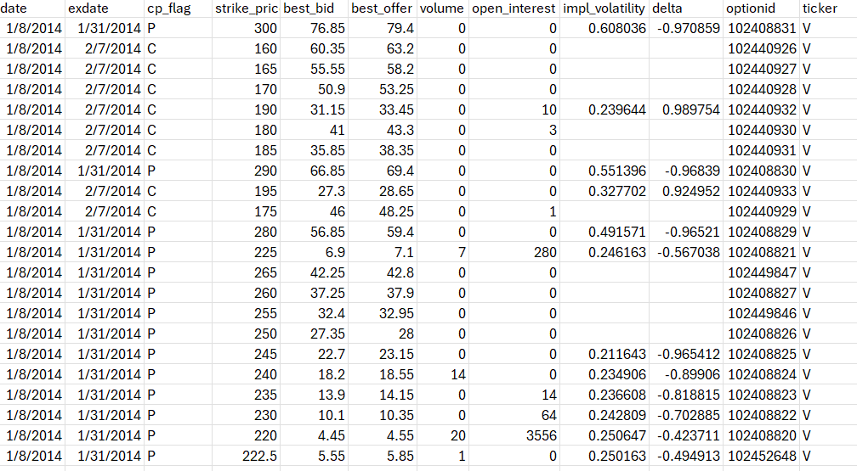

Figure 1. A representation of how the option dataset looks like for Visa (ticker: V) on 08.01.2014. The dataset is multi-indexed, meaning that each row represents a unique combination of: Trade date – Expiration Date – Strike Price – Option Type (Call/Put)

One can see in Figure 1 that the Option Metrics database is a multi-indexed flatten series with 4 degrees of abstraction. Therefore, on a given trading day there are multiple option chains present in the market (different expiration dates) and each option chain contains multiple strike prices (different strike prices) for each of which there is a call and a put present.
It is important to note that the full IvyDB Database goes back to January 1996, is around 1.8 TB and contains option data of all US public companies which had listed options. The size of the dataset therefore necessitates certain design considerations for this paper. The first being that only options of companies with a market capitalization above USD 1 billion are queried – this is done in an attempt to reduce the amount of data that has to be downloaded as micro-cap companies are unlikely to have liquid enough options that allow a trader to “sell” the earnings event. Secondly, the sample period starts only from 2014, which is done partially to reduce the size of the data with which I work but also because fitting machine learning models on data so far in the past (this paper is written in 2026), is unlikely to generalize well to out of sample performance in the present more than a decade later.
The data-acquisition looks as follows. To only isolate companies above the USD 1 billion threshold, I downloaded the whole CRSP (CCM) Database with daily closing prices and the number of shares outstanding for each US listed company for the sample period (01.01.2014 – 31.12.2024). I save the tickers of all such companies whose Market Capitalization (Closing Price * Number of Shares Outstanding) exceeded the 1 billion mark at any point in time during the sample period i.e. a company would be included in the ticker list if there was at least one day (t = 0) where its market capitalization was above USD 1 billion. This amounted to 2270 tickers.
The 2270 tickers were split into batches of 227 and each batch was downloaded from the WRDS portal with the restriction that options with Days Until Expiration (DTE) > 60 are excluded – this is done because the trading strategy proposed in this paper focuses on short term options with DTE less than a month. Subsequently, after each batch is downloaded, the output is a .csv file of 10GB or more, therefore, to be manageable each batch is ingested into the computer memory in chunks of 500 000 rows and each chunk is then mapped to ticker unique csvs for each company present. Basically, at the end of this procedure I am left with 2270 csv files, each containing all the option data for a given company.
Earnings announcement dates are downloaded from the I/B/E/S database on WRDS. The resulting file contains the announcement date and time for each quarterly earnings report for each US publicly listed company for the period 01.01.2014 – 31.12.2024.
Afterwards, each option csv file (all 2270 of them) undergoes further preprocessing. Firstly, the strike price is divided by 1000 – this is necessary as strike prices in the IvyDB database are multiplied by 1000 of their actual value. Secondly, meta data columns regarding exercise style, index flag and issuer are dropped. Thirdly, event windows are constructed around the earnings report dates, with the caveat that if an earnings announcement falls during regular trading hours (09:30 – 16:00) it is dropped from the dataset. Since earnings announcements can be reported either Before Market Hours or After Market Hours, the event window follows the logic that t = 0 is always the last trading day before the event was announced. Explained simply, if Microsoft announces earnings tonight after market close, t = 0 is today, as positioned can be entered up until the close of the market today. However, if Microsoft releases earnings tomorrow before market open, t = 0 is today as the last time that positions regarding this earnings event (Short ATM Straddles) can be entered is the market close tonight. Using this logic, I construct an event window that counts in t the business days before or after the event. The event window on which this paper focuses is t [-15, 1], where t = 1 represents the close of the first trading day after the announcement, observations for days outside the range are dropped. For the days within the event window, all rows whose option expiration date are at or before t = 0 are also removed. Finally, if an event window has missing values for t = 0 or that there are more than 2 days within t [-15, 1] which are absent, the whole earnings event window is removed from the panel data.
Furthermore, a couple of additional columns are created for each option csv – Day-To-Expiration (DTE) computed as calendar days between the date and expiration date, After Market – a binary variable 1 if the nearest earnings announcement happens After Trading Hours and 0 otherwise, Day Of The Week – the day of the week which corresponds to t=0, encoded as 0 = Monday to 4 = Friday.
Using this preprocessing approach the overall option data is drastically reduced in size to 13.7GB with the average of the 2270 option-ticker csv files consisting of 73 628 rows. Additionally, I also download a daily VIX timeseries from the LSEG Datastream on WRDS, a risk-free rate series from the CRSP Risk Free – 4 week (Nominal) and SP500 daily close timeseries from CRSP which are used for feature engineering.
A total of 24 features (explanatory variables) are calculated for each earnings announcement event, since some of the features have a lookback of 8 earnings events, feature calculations start with events from 01.01.2016:

- Hawkes Process
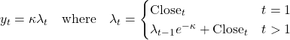

Following the findings of Bacry et al(2015), I use the discretization of the Hawkes Process to capture the self-exciting nature of volatility and the phenomenon of volatility clustering, the main difference is that in the current paper I use daily data, while in the original paper the authors use tick data. I use 42 daily bars of lookback to calculate the Hawkes Process.The value of the Hawkes Process at t = 0, is saved as an explanatory variable.

- Reversibility Index (R): 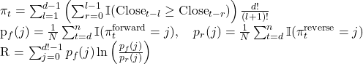
In the paper I use d = 42 (lookback of 2 months) and l = 3 (dimension of the entropy embedding). This feature is inspired by the implementation of Zanin et al (2018), who argue that time irreversibility is a signature of systems operating out of equilibrium, which basically implies that when the Reversibility Index is high movements are less likely to be random hence the market is efficient. Clearly, such an explanatory variable is of great importance to a trading system, which “bets” on smaller than implied moves over earnings. The value of the Reversibility Index at t =0 is saved.

- Relative Strength Index (RSI)
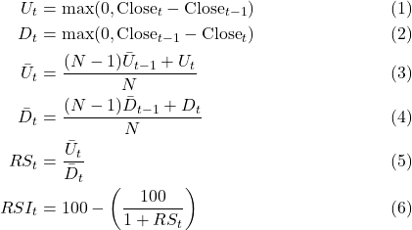

The RSI is an implementation of the concepts introduced by Wilder (1978). The idea is that the RSI maps momentum to a normalized [0, 100] range, creating a velocity metric which is independent of the absolute price level of the stock. The RSI is calculated using a lookback of 14 daily candles, which is what Wilder (1978) uses and the value at t = 0 is used as an explanatory variable in the model.

- Volatility Ratio
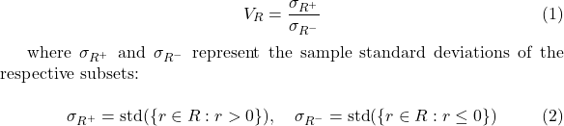

The Volatility Ratio represents the ratio between the standard deviation of positive returns in the sample divided by the standard deviation of negative returns in the sample. This feature is inspired by Baekaert & Wu (2000), who document that downside volatility reacts more sharply to negative returns than upside volatility to positive ones, implying that there I asymmetry in how the market incorporates opposing shocks. Hence, such a measure is of interest to this paper, as it might contain information about the state of the market, which might influence the profitability of selling earnings. The Ratio is calculated with a lookback of 42 trading days and its value at t = 0 is used as an explanatory variable.

- Idiosyncratic Volatility
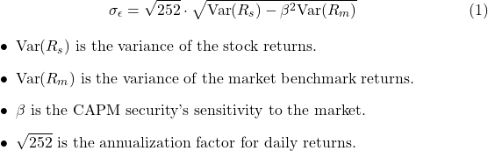
This is the Idiosyncratic volatility calculated based on the realized variance of the stock returns, the market (SP500) and their CAPM beta over the last 42 trading days. The value of the idiosyncratic volatility at t = 0 is used as an explanatory variable.

- Abnormal Volume Calls
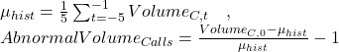

The Abnormal Call Volume is a comparison between the average volume in the last 5 business days before t = 0 and the Call Volume traded at t = 0. According to Easley, O’Hara and Srinivas (1998) a spike in the volume traded calls of can have a significant predictive power for future stock price increases. Therefore, in this paper such a measure could be useful as it might signal upside pressure before the earnings event. The value at t = 0 is used.

- Abnormal Volume Puts
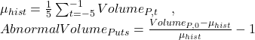
Same concept as the Abnormal Put Volume, again Easley et al (1998) suggest that spikes in such a measure could indicate informed traders who have ‘bad news’ about a stock. The value at t = 0 is used.

- Aftermarket Dummy
A binary variable: 1 if the earnings release at t = 0 was announced After Trading Hours and 0 if it occurred Before Trading Hours. This variable is included based on Bacry et al’s (2015) research which claims that price discovery in earnings released After Market Hours is more saturated in liquidity-moving traders such as portfolio managers, while those in the early morning tend to reflect more primitive information and tend to be less noisy.

- ATM Call Open Interest Ratio
This variable is computed as the ratio between the Open Interest of the At-The-Money Call at t =0 (ATM here is defined as the strike price K, whose absolute distance from the stock price at close is the smallest) divided by the total open interest of the entire options chain. The options chain, which is selected for the calculations is referred to as ‘The Front Month’ and it is the nearest option expiration at t = 0. The idea for this feature comes from Fodor, Krieger & Doran (2011) who document that large increases in call open interest tend to be followed by significant equity returns. The ATM Call Open Interest ratio is computed at t = 0.

- ATM Put Open Interest Ratio

The ATM Put Open Interest Ratio follows the same logic as that for the ATM Call Open Interest Ratio (Feature #9). The theoretical grounds for its use are provided again by Fodor, Krieger & Doran (2011) who find a negative relationship between Open Interest Changes and forward stock returns. Additionally, there is also the hypothesis to consider that retail traders (uninformed traders) tend to buy Out-Of-The-Money (OTM) options in the days preceding earnings announcements expecting a big move, hence such a feature as proposed here would be able to capture excess retail positioning which would likely overestimate the earnings realized move. Again the ATM Open Interest Ratio is computed at t = 0.

- Call / Put Open Interest Ratio

To wrap up the option orderbook features, this explanatory variable takes the sum of the Open Interest for both Calls and Put at t = 0 for the nearest expiration and computes the ratio between them. As mentioned in Feature #9 and #10, an imbalance between calls and puts could signal significant positioning by the market for a large bullish or a bearish move, either of which would be detrimental to this paper’s strategy or selling ATM Straddles.

- CAPM Beta
The CAPM Beta between the returns of the Stock and the SP 500, computed with a lookback of 42 trading days (2 months). The value at t = 0 is used in the model. The rationale is that stocks with higher systemic risk tend to be more volatile, hence it is likely that higher beta companies would exhibit a larger magnitude of their Close-to-Close earnings moves.

- Day of the Week
The day of the week on which the announcement is scheduled regardless if it is before or after market. Days of the week are encoded as integers 0 for Monday up until 4 for Friday.

- Implied Skew Change

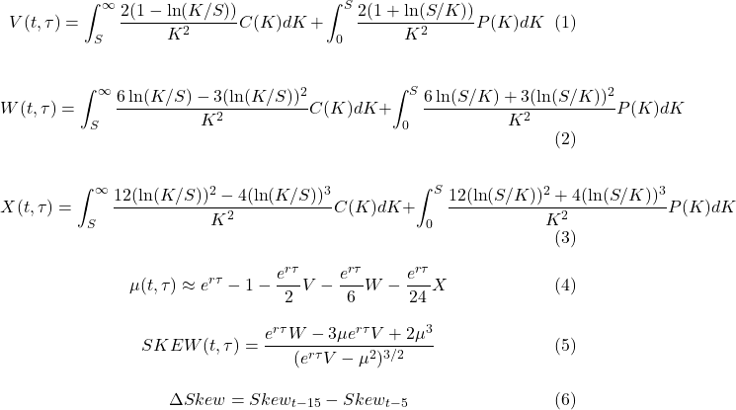
The model-free change in skewness follows the implementation of Bakshi, Kapadia & Madan (2003). The integrals are approximate via the trapezoid rule, where at least 3 OTM Calls and 3 OTM Puts are required, if this is not satisfied this variable is set to NaN. The feature is calculated by subtracting the implied skewness at t = -5 from the implied skewness at t = -15, the option chain used is the nearest expiration after t = 0. Conrad, Dittmar & Ghysels (2013) motivated the inclusion of this feature, as their research suggests that ex-ante positive changes in risk-neutral skewness before earnings events tend to signal subsequent large abnormal returns after the event and vice versa for decreases.

- Implied Kurtosis Change
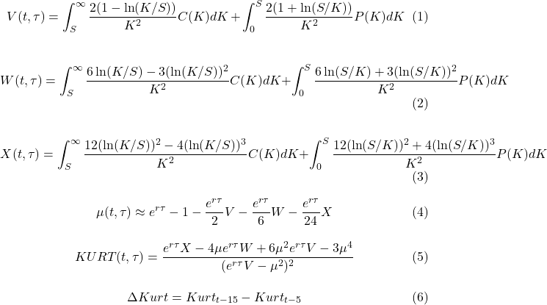

The Implied Kurtosis Change follows the same algorithm as the Implied Skew Change (Feature #14). Conrad, Dittmar & Ghysels (2013) report that rise increases in the implied kurtosis of the option chain could signal higher tail risk for the subsequent earnings event. Again, the difference between the values at t = -15 and t = -5 is used.

- Log Market Capitalization
The use of the Log Market Capitalization follows the findings of Gao, Xing & Zhang (2018) who document that buying Long Straddles and holding them over earnings announcements (the opposite of what this paper is doing) exhibit positive returns for small cap companies. The authors suggest that due to the conservativism bias of investors, option traders tend to underestimate the uncertainty for this subset of firms. Consequently the IV crush is less pronounced for small caps, which hurts the profitability of this paper’s strategy – selling ATM straddles over earnings. The Log Market Cap is the natural logarithm of the product of the shares outstanding and closing price at t = 0.

- Implied Move
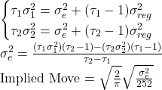

This is one of the most important features for this paper, mainly the implied move that the option market attributes ex-ante to the earnings move. To calculate it I take the nearest 2 option expirations after t = 0 and use the Mid Implied Volatility for the ATM strikes (ATM is the strike closest to the current stock price). The feature is calculating by solving a linear system, which tries to isolate the event variance for the stock’s regular variance. This measure is widely used in the trading industry (Bloomberg L.P, 2024) as well as by Durbinsky (2018). The implied move is calculated at t = 0.

- Implied Volatility
This is the average of the Mid IV of the Put and Call for the ATM strike at t = 0 for the nearest expiration after earnings. ATM is defined as the strike price closest to the current stock price. The value of the implied volatility at t = 0 is used as a feature.

- IV Slope
This is the time-weighted difference between the Implied Volatility of the 2 nearest expirations after the earnings event. The implied volatilities are taken as the average of the IVs of the Mid prices of the ATM Calls and Puts for both the front and back month expirations. The value at t = 0 is used.

- VIX
The value of the VIX index at t = 0. The use of this feature is motivated by Li & Zhao (2009) who report that stock exhibit larger abnormal returns around earnings during periods of high VIX.

- Earning Standard Deviation (8)
The standard deviation of the absolute returns from close to close from t = 0 to t = 1 of the previous 8 earnings events for a given company. If less than 8 earnings events are available (the company went public recently) I take the standard deviation of the earnings up to the present point. The rationale for this feature is that if the magnitude of the realized earnings moves varies a lot, this makes selling straddles rather risky, so such an explanatory variable should be able to capture this vector of uncertainty.

- Absolute Realized Move (1)
Isakov & Perret (2015) report that companies that have experienced a large absolute price move in response to an earnings announcement are statistically more likely to experience moves of similar magnitude in subsequent announcements. This feature is calculated as the close to close return from t = 0 to t=1 for the previous earnings move.

- Absolute Realized Move (2)
Same logic as Feature #22, this one is the close to close from t = 0 to t = 1 absolute realized move from the second to last earnings announcement.

- PNL (8)
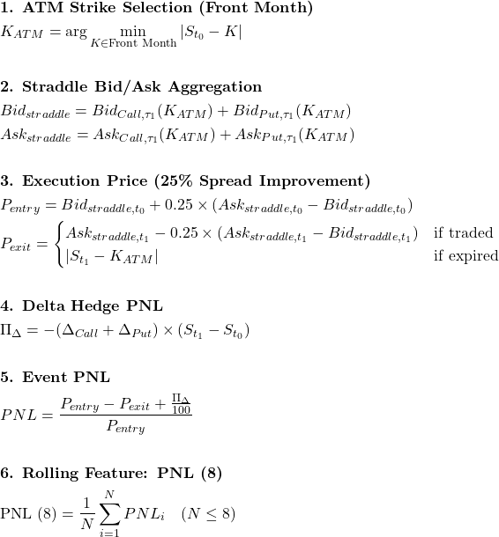

As eluded to earlier in the paper the strategy which I focus on is selling an ATM straddle at t = 0 and buying it back at t = 1 using the nearest option expiration referred to as ‘front-month’, the at the money strike is defined as the nearest strike to the close price at t = 0. A Short Straddle is constructed by selling a Put and a Call. Battalio, Hatch & Jennings (2004) find that the quotes in the IvyDB Database (the one that this paper is using) are too conservative and that real-sized order can be executed with an improvement of 25%-35% of the quoted spread, hence why to enter and exit the Straddle this paper assumes only paying 75% of the spread. This is still relatively conservative, as authors like Murayev & Pearson (2020) show that option trading costs are overestimated by a factor of 2 to 3 times i.e. option positions could be executed around the mid-price in a real world setting. Upon entry Short Straddles are delta hedged. There are a couple of additional rules which are enforced in order to ensure that straddles represent tradable opportunities:
- A Straddle would not be entered (and all the other features would be saved as NaN) if the absolute delta difference between the Call and the Put is greater than 20 – this is done to safe guard against positions in stocks with a low market price, where due to strike prices being discrete (Strike Prices being present at every integer value for example) there does not exist an option pair with a symmetric risk suitable for a Short Straddle.
- A Straddle would not be entered (and all the other features would be saved as NaN) if the spread (the difference between the Best Offer and Best Bid) for either the Call or the Put is larger than the bid price. Basically, this safeguards against entering the most illiquid of options, where the quotes are stale to the point that the spread is larger than the value for which the option can be sold, which in reality no trader would trade.

All in all, the 24 features each are saved each into a unqiue 2D matrix across the dimensions of time (the Quarter and Year the earnings was reported) and the stock ticker. The final X matrix, which is used for forecasting is obtained by flattening the 24 feature matrixes into one table where each row of the table represents 1 earnings event for a given stock ticker. Events are dropped if no Straddle trade occurs (more than 20 Delta to be hedged or Bid-Ask Spread > Bid Price), the announcement time is between regular trading hours (09:30 – 16:00), the market cap of the company at t = 0 is less than USD 1 billion, there are less than 15 observation for the trading days in the event window t [ -15, 1], data for the ATM options on t = 0 is missing or close for t = 0 or t = 1 in unavailable.

Reference List:
Bacry, E., Mastromatteo, I., & Muzy, J. F. (2015). Hawkes processes in finance. Market Microstructure and Liquidity, 1(01), 1550005. https://doi.org/10.1142/S2382626615500057

Bekaert, G., & Wu, G. (2000). Asymmetric volatility and risk in equity markets. The Review of Financial Studies, 13(1), 1-42. https://doi.org/10.1093/rfs/13.1.1

Bakshi, G., Kapadia, N., & Madan, D. (2003). Stock return characteristics: Evidence from stock options. The Review of Financial Studies, 16(1), 101–143. https://doi.org/10.1093/rfs/hhg030

Bali, Beckmeyer, Moerke, Weigert (2021) ‘Option Return Predictability with Machine Learning and Big Data’ CFR Working Paper No. 21-08, Centre for Financial Research (CFR), University of Cologne

Barber, De George, Lehavy & Trueman (2012), ‘The Earnings Announcement Premium Around the Globe’ Journal of Financial Economics (SSRN Working Paper 2501750)

Barth, Mary E., and Eric C. So (2014).
“Non-Diversifiable Volatility Risk and Risk Premiums at Earnings Announcements.” The Accounting Review, 89(5), 1579–1607.
DOI: 10.2308/accr-50758

Battalio, R., Hatch, B., & Jennings, R. (2004). Toward a more ethical stock market: The nature and causes of price improvement in the options market. Journal of Financial and Quantitative Analysis, 39(2), 287–304. https://doi.org/10.1017/S002210900000305X

Bloomberg L.P. (2024). Expected Earnings Move (MOVE) Functionality. Bloomberg Professional Service.

Conrad, J., Dittmar, R. F., & Ghysels, E. (2013). Ex ante skewness and expected stock returns. The Journal of Finance, 68(1), 85–124. https://doi.org/10.1111/j.1540-6261.2012.01795.x Cited by: 1111

DellaVigna, Stefano, and Joshua M. Pollet (2009).
“Investor Inattention and Friday Earnings Announcements.” The Journal of Finance, 64(2), 709–749.
DOI: 10.1111/j.1540-6261.2009.01447.x

Diavatopoulos, Dean; Doran, James S.; Fodor, Andy; Peterson, David R. (2012).
“The Information Content of Implied Skewness and Kurtosis Changes Prior to Earnings Announcements for Stock and Option Returns.” Journal of Banking & Finance, 36(3), 786–803.
DOI: 10.1016/j.jbankfin.2011.09.011

de Silva, T., Smith, C. J., & So, E. C. (2022). Losing is optional: Retail option trading and expected announcement volatility. SSRN Electronic Journal. https://doi.org/10.2139/ssrn.4116805

Durbinsky, Johannes, Kaeck & Seeger (2018) ‘Option Pricing of Earnings Announcement Risks’ The Review of Financial Studies, Volume 32, Issue 2, February 2019, Pages 646–687, https://doi.org/10.1093/rfs/hhy060

Easley, D., O'Hara, M., & Srinivas, P. S. (1998). Option volume and stock prices: Evidence on where informed traders trade. The Journal of Finance, 53(2), 431-465.

Fodor, A., Krieger, K., & Doran, J. S. (2011). Do option open-interest changes foreshadow future equity returns? Journal of Futures Markets, 31(3), 243-260. https://doi.org/10.1002/fut.20467

Gao, C., Xing, Y., & Zhang, X. (2018). Anticipating uncertainty: Straddles around earnings announcements. Journal of Financial and Quantitative Analysis, 53(6), 2587–2617. https://doi.org/10.1017/s0022109018000285

Govindaraj, Jin, Livnat & Zhao (2014) ‘Using Option Implied Volatilities to Predict Absolute Stock Returns – Evidence from Earnings Announcements and Annual Shareholder Meetings’

Goyal & Saretto (2009) ‘Cross section of option returns and volatility’

Hirshleifer, David; Lim, Sonya S.; Teoh, Siew Hong (2009).
“Driven to Distraction: Extraneous Events and Underreaction to Earnings News.” The Journal of Finance, 64(5), 2289–2325.
DOI: 10.1111/j.1540-6261.2009.01501.x

Interactive Brokers. (2024). Margin requirements. https://www.interactivebrokers.com.au/en/trading/marginRequirements/marginUSOptions.php

Isakov, D., & Perret, C. P. (2015). Are stock price reactions to earnings announcements predictable? Journal of Banking & Finance, 60, 230–240. https://doi.org/10.1016/j.jbankfin.2015.08.012

Kelly, B., L. Pástor, and P. Veronesi. 2016. The price of political uncertainty: Theory and evidence from the option market. Journal of Finance 71:2417–80.

Larmont & Frazzini (2007), ‘The Earnings Announcement and Trading Volume’ (NBER Working Paper 13090)

Lei, Qin; Wang, Xuewu (Wesley); Yan, Zhipeng (2017).
“Volatility Spread and Stock Market Response to Earnings Announcements.” Journal of Banking & Finance, 81, 44–61.
DOI: 10.1016/j.jbankfin.2017.04.002

Li, J., & Zhao, X. (2009). VIX and the earnings announcement premium. Financial Management, 38(1), 1–21. https://doi.org/10.1111/j.1755-053x.2009.01026.x

Lipkin M., and Tatevossian (2024). “Earnings Moves and Pre-Earnings Implied Volatility.” Journal of Risk, Volume 27, Number 2, pp. 77–94.DOI: 10.21314/JOR.2024.016 [risk.net]

Muravyev, D., & Pearson, N. D. (2020). Options trading costs are lower than you think. The Review of Financial Studies, 33(10), 4973–5014. https://doi.org/10.1093/rfs/hhz146

Patell, J. M., and M. A. Wolfson. 1979. Anticipated information releases reflected in call option prices. Journal of Accounting and Economics 1:117–40.

Patell, J. M., and M. A. Wolfson. 1981. The ex ante and ex post price effects of quarterly earnings announcements reflected in option and stock prices. Journal of Accounting Research 19:434–58.

Patell, J. M., and M. A. Wolfson. 1984. The intraday speed of adjustment of stock prices to earnings and dividend announcements. Journal of Financial Economics 13:223–52

Rogers, Jonathan L.; Skinner, Douglas J.; Van Buskirk, Andrew (2009).
“Earnings Guidance and Market Uncertainty.” Journal of Accounting and Economics, 48(1), 90–109.
DOI: 10.1016/j.jacceco.2009.07.001

Savor & Wilson (2016), ‘Earnings Announcements and Systemic Risk’, Journal of Finance, 71(1), 83-138

Wilder, J. W., Jr. (1978). New concepts in technical trading systems. Trend Research.

Zanin, M., Rodríguez-González, A., Menasalvas Ruiz, E., & Papo, D. (2018). Assessing time series reversibility through permutation patterns. Entropy, 20(9), 665. https://doi.org/10.3390/e20090665

